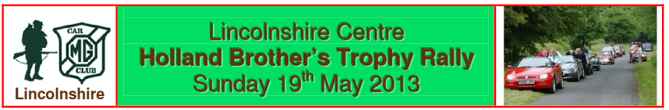N.B. Personal data is collected by the Club to allow proper administration of this event
Lincolnshire Centre
Jubilee Trophy Rally
Sunday 7th October 2018
1. Lincolnshire Centre of the MG Car Club will promote a Navigational Scatter Rally on Sunday 7th October 2018.
2. An M.S.A. permit has been applied for.
3. The event is open to all fully elected members of the promoting club. Club membership cards will be inspected at signing-on.
4. The programme of the event will be as follows:- Arrive for Coffee and Bacon Bap at 9.00 a.m.
Instructions will be handed out at 9.15 a.m. First car away at 9.45 a.m.
The event is not timed, and the rally should take approximately 2-2½ hours. Any car and entrants not returned by 1.30 p.m. will be excluded from the results.
5. This is a test of navigational skills. Use of GPS systems or any similar navigational aid is prohibited and will result in exclusion.
6. The winning team will receive the Jubilee Trophy which will be presented at the Lincolnshire
Centre’s Annual Dinner and Dance on Saturday 2nd February 2019
7. The maximum number of entries is 12.
8. The entry list opens on 1st July 2018 and closes on the day of the event
9. The entry fee is £13.50. All Cheques/POs should be made payable to the “MG Car Club”.
10. The Secretary of the event, to whom entries must be sent, is:- Paul Smith (Tel:) 07919 915944
11. You will require:- OS Map 130 1:50,000 scale Landranger Series
A Pencil and Eraser, A roamer or metric ruler, A navigator and a car with a working milometer
12. The start location will be Wymondham Windmill, Butt Lane, Wymondham, Melton Mowbray, LE14 2BU (Grid Ref 852 192).
13. Coffee and bacon rolls etc. will be available at the start – there is no requirement to pre-order. Lunch will be available after the event at International Bomber Command Centre, Canwick Hill, Lincoln LN4 2HQ (Map 121 Grid Ref 986 694).
PLEASE CUT HERE
ENTRY FORM - I wish to enter the Jubilee Trophy Rally on Sunday 7th October 2018.
Name . . . . . . . . . . . . . . . . . . . . . . . . . . . . . . . . . . . . . . . Membership Number: . . . . . . . . . . . . . . . . . . . . . .
Address . . . . . . . . . . . . . . . . . . . . . . . . . . . . . . . . . . . . . . . . . . . . . . . . . . . . . . . . . . . . . . . . . . . . . . . . . . . . . . . . . . . . . . . . . . . . . . . . . . . . . . . . . . . . . . . . . . . . . . . . . . . . . Postcode . . . . . . . . . . . . . . . . . . . . . . . . . . . . Telephone . . . . . . . . . . . . . . . . . . . . . Mobile Number . . . . . . . . . . . . . . . . . . . . . . . . . . . . . . .
My Navigator will be (member/non-member) ………………….………………………….. Email . . . . . . . . . . . . . . . .. . . . . . . . . . . . .
Car Make . . . . . . . . . . Model . . . . . . . . . . . . . . . . . . . . Year . . . . . . Registration Number . . . . . . . . . . . . .
I enclose my Entry Fee of £13.50 made payable to “MG Car Club”
PLEASE SEND YOUR COMPLETED ENTRY FORM AND ENTRY FEE to Paul Smith, 21 Northfields, Bourne, PE10 9DB

