LINCOLNSHIRE POACHER CONCOURS AND PRIDE OF OWNERSHIP SHOW 2019
SUNDAY 18 AUGUST 10AM – 4PM
DODDINGTON HALL AND GARDENS
DODDINGTON
LINCOLNSHIRE LN6 4RU

Set within spectacular gardens, Doddington Hall, Doddington, near Lincoln is an example of a fine late Elizabethan mansion house and is, for the seventh year, the venue for the MG Car Club Lincolnshire Centre’s flagship event sponsored by Peter Best Insurance, the Lincolnshire Poacher Concours and Pride of Ownership Show.

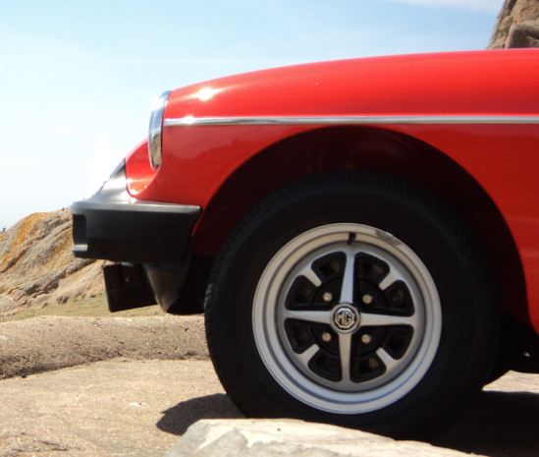

Enjoy a great day at a special location

Classic Cars of any marque and particularly MGs of all models welcome! Rosettes will be awarded to winning cars on the day with fabulous trophies presented at the Centre’s annual Dinner Dance in January 2020.

Refreshments are available throughout the day.

Winners of each Show Class, the Premier Concours and the Premier Condition award winners will be announced at the club marquee at 3pm.

.

Don’t forget – for those that don’t want to enter their car to be judged, the day is still open for you to come along for a relaxing day out at no charge.

Full details available on www.mgcclincolnshire.co.uk
or contact Geoff and Vicki Edge on 01205 871973 geoffjedge@aol.com
www.doddingtonhall.com
LINCOLNSHIRE POACHER CONCOURS AND PRIDE OF OWNERSHIP SHOW 2019
SUNDAY 18 AUGUST 10AM – 4PM
DODDINGTON HALL AND GARDENS
DODDINGTON
LINCOLNSHIRE LN6 4RU

ENTRY FORM – PLEASE RETURN THIS SECTION – entry acknowledgement will be sent by email
PAYMENT OF £5 FOR SHOW PRE-ENTRY MUST BE MADE IN ADVANCE (BY FRIDAY 16 AUGUST 2019). ENTRIES ON THE DAY ARE £7.50.
Name…………………………………………………………………………………………………………………………….
Address………………………………………………………………………………………………………………………….
………………………………………………………………………..Postcode………………………………………………
Tel. No…………………………………………………………….Mobile………………………………………………….
Email address………………………………………………………………………………………………………………..
CLASSES – PLEASE CIRCLE THE CLASS ENTERED
Class 1 | MG Vintage (MMM, T, Y and SVW);
Class 2 | MGA, Twin Cam and Magnettes
Class 3 A | MGB,, MGC
Class 3 B | MGB GT, MGCGT
Class 4 | MG Midget/other MG
Class 5 | MGF
Class 6 | MGTF
Class 7 | RV8, ZR, ZS, ZT, MG3/6
Class 8 A | Non MG (pre 1970)
Class 8 B | Non MG (post 1970)
Class 9 | Elite (previous Elite Class/Premier Concours/Premier Condition winners, previous major event winners last 3 years)

CarMake…………………………………………………………..CarModel……………………………………………………Year………………………………………………………………….Reg.No………………………...................................
In addition to each Class winner there are 2 further major trophies for : Premier Concours Car and Premier Condition Car
IMPORTANT - All entrants: (please tick box)
Do you wish to be judged on the basis of:
ORIGINALITY (Concours/as factory)
OR CONDITION (modified/Pride of Ownership)

PAYMENT
I enclose a total of …………………. cheques to be made payable to “MG Car Club”. Please return forms to: GEOFF AND VICKI EDGE, WILLOW TREE BARN, HURNS END, OLD LEAKE, BOSTON, LINCS PE22 9JN Closing date for pre-entries is Friday 16 August 2019.

Full details available on www.mgcclincolnshire.co.uk
or contact Geoff and Vicki Edge on 01205 871973 geoffjedge@aol.com

