The Bath Gymkhana 31.5.9

There is so much to think about ! Back in the autumn of last year, sitting round the Committee table trying to thrash out the dates of the 2009 calendar, whilst having to keep great swathes of it open until the dreaded Silverstone date is decided on by those higher up the food chain, the school half term holidays didn’t enter the collective brain.

So it was that we decided to hold the Bath Gymkhana in the middle of a deliriously sunny 9 day school half term holiday—with the result that most of the family orientated prospective competitors were away in some holiday destination or other being dutiful parents.

This was a pity as, for the organiser, it is rather disappointing to put all the effort into running the event for less than, perhaps, 20 entrants. As it was this year the younger farmers Breach cut the meadow at Charmy Down for us and kept the cows off for a few days so there weren’t any soft cow pats to dirty the underside—jolly thoughtful I call that.

Years ago, when I first started entering this sort of thing, the majority of entrants were in the MMM register with a few T types and the odd Vintage car. This year we had representatives from MGF, MGB, Metro, Midget and just a couple of T types—how things have changed.

Those that were there enjoyed 3 attempts at the 8 tests laid out (both timed and ‘judgement’) with only the best 2 scores to count (so if you fouled up the first run it didn’t ruin the rest of the afternoon for you).

This time, due to lack of rain, the ground was hard with plenty of grip so the tests were set somewhat ‘tighter’ than normal to keep speeds down and give all classes a reasonable chance of overall success. There was an added twist in that the ‘Two Towed Tyre’ machine was shamelessly stolen for the ‘Butterfly’ test from our friends the Chew Magna—well Dave Coppock’s twisted imagination anyway. This device consists of two old tyres (as the quick amongst you will have already surmised) tied together with some stout rope and then attached to the rear of the entrant’s car in such a way as to be towed round the test some 10 feet behind. Go too fast and the tyres bounce about all over the place hitting down bollards left and right (as Dave Mothersdill so eloquently demonstrated in his first attempt). Cut the corners too fine and again the rope will drag away your points (you attract a 10 second penalty for every bollard upturned). All this added greatly to the amusement of the fellow competitors and spectators and though the marshals didn’t quite see the funny side after picking up the cones for the 100th time……..

The event is run as an afternoon effort so lunch can be had in one of the beautiful local pubs, it is but 20 minutes from the M4 so access is easy and it is all over by tea time so you still get home at a reasonable time—what more could anyone ask ? As it is so near the Bristol/Bath population centre of the S.W. Centre you would normally expect that most of the competitors would have come from the local environs but not so—they came from Taunton, Northants, LLanbudder (South West Wales, of course), South Gloucestershire and but 2 from Bath with none at all from Bristol—an odd world isn’t it ?

Ian Webb (who we hadn’t seen for years until the 2008 Bath Gymkhana and wiped the floor with everybody) came again in his Midget but this time provisional results show that he was trounced into 3rd place by overall winner John Dellafield (Midget) and Peter Jones (TC) with Frank Vautier (TA) 4th so perhaps we got the course a little too tight for the bigger cars—never mind, next year it will be different.

If you would like to see the site go to Google Maps and tap in BA1 8AF then click the ‘Satellite’ tab. Follow the dirt road off the A46 Gloucester Road to the ‘T’ and turn left. Go to the next ‘T’ and turn right—the rectangular light green field immediately on your right is the one we use and you can still see the tyre tracks of the courses we used that year ! The chap who said that the only man made thing you can see from space is the Great Wall of China obviously hadn’t come across the S.W. Centre !

The collection of ‘photos that our esteemed editor may care to print along side this small piece should give you some idea of what NOT to do to win prizes but you may get some idea of the fun and enjoyment to be had by entering the less serious ‘grass roots’ events run by the various centres of the M.G.C.C.—go to http://www.mgcc.co.uk and click the ‘Events’ tab to see what is going on near you !

Finally grateful thanks to Victoria Jones for doing all the organising effort and to Jeremy Hawk and the entire Tyler family for coming along to marshal the event for us. We are also grateful the Breech family for yet again making us so welcome on their land.

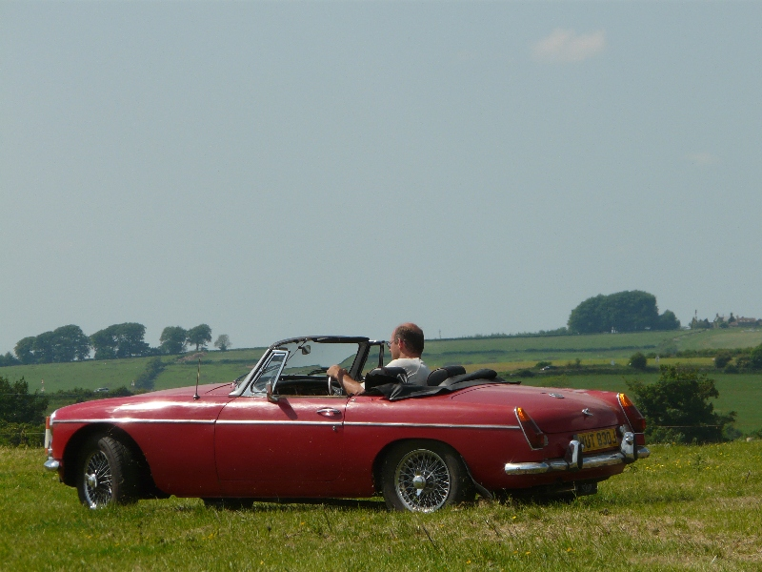
Dave Mothersdill in his 'new' MGB on his first outing
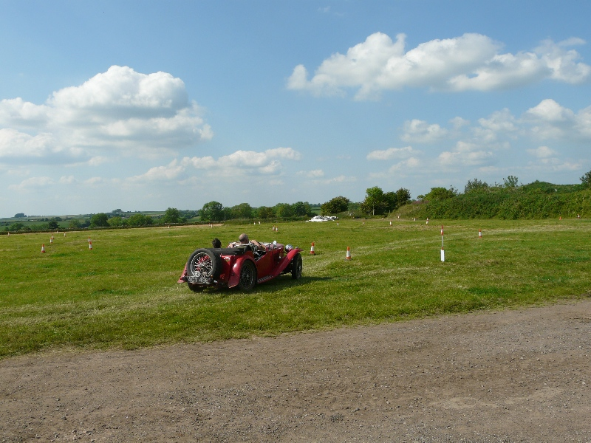
Look at the beauty that surrounds this wonderful site, pity about the TA in the way

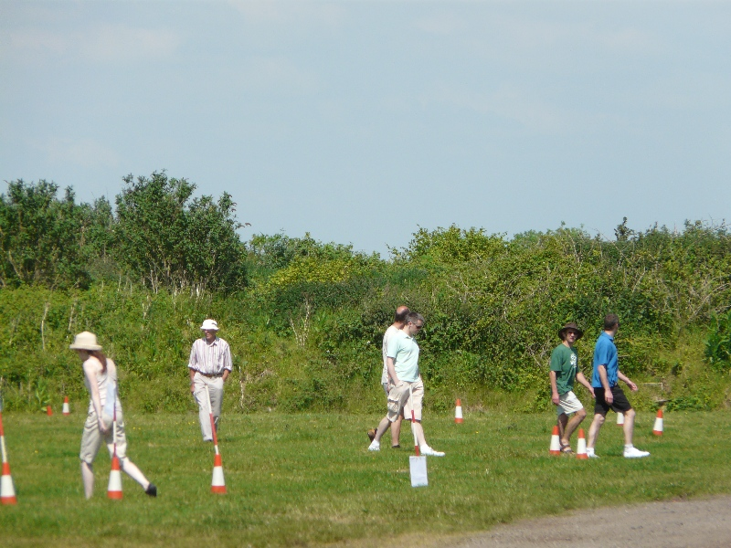
Looks like a cricket match but actually entrants 'walking' the first test

