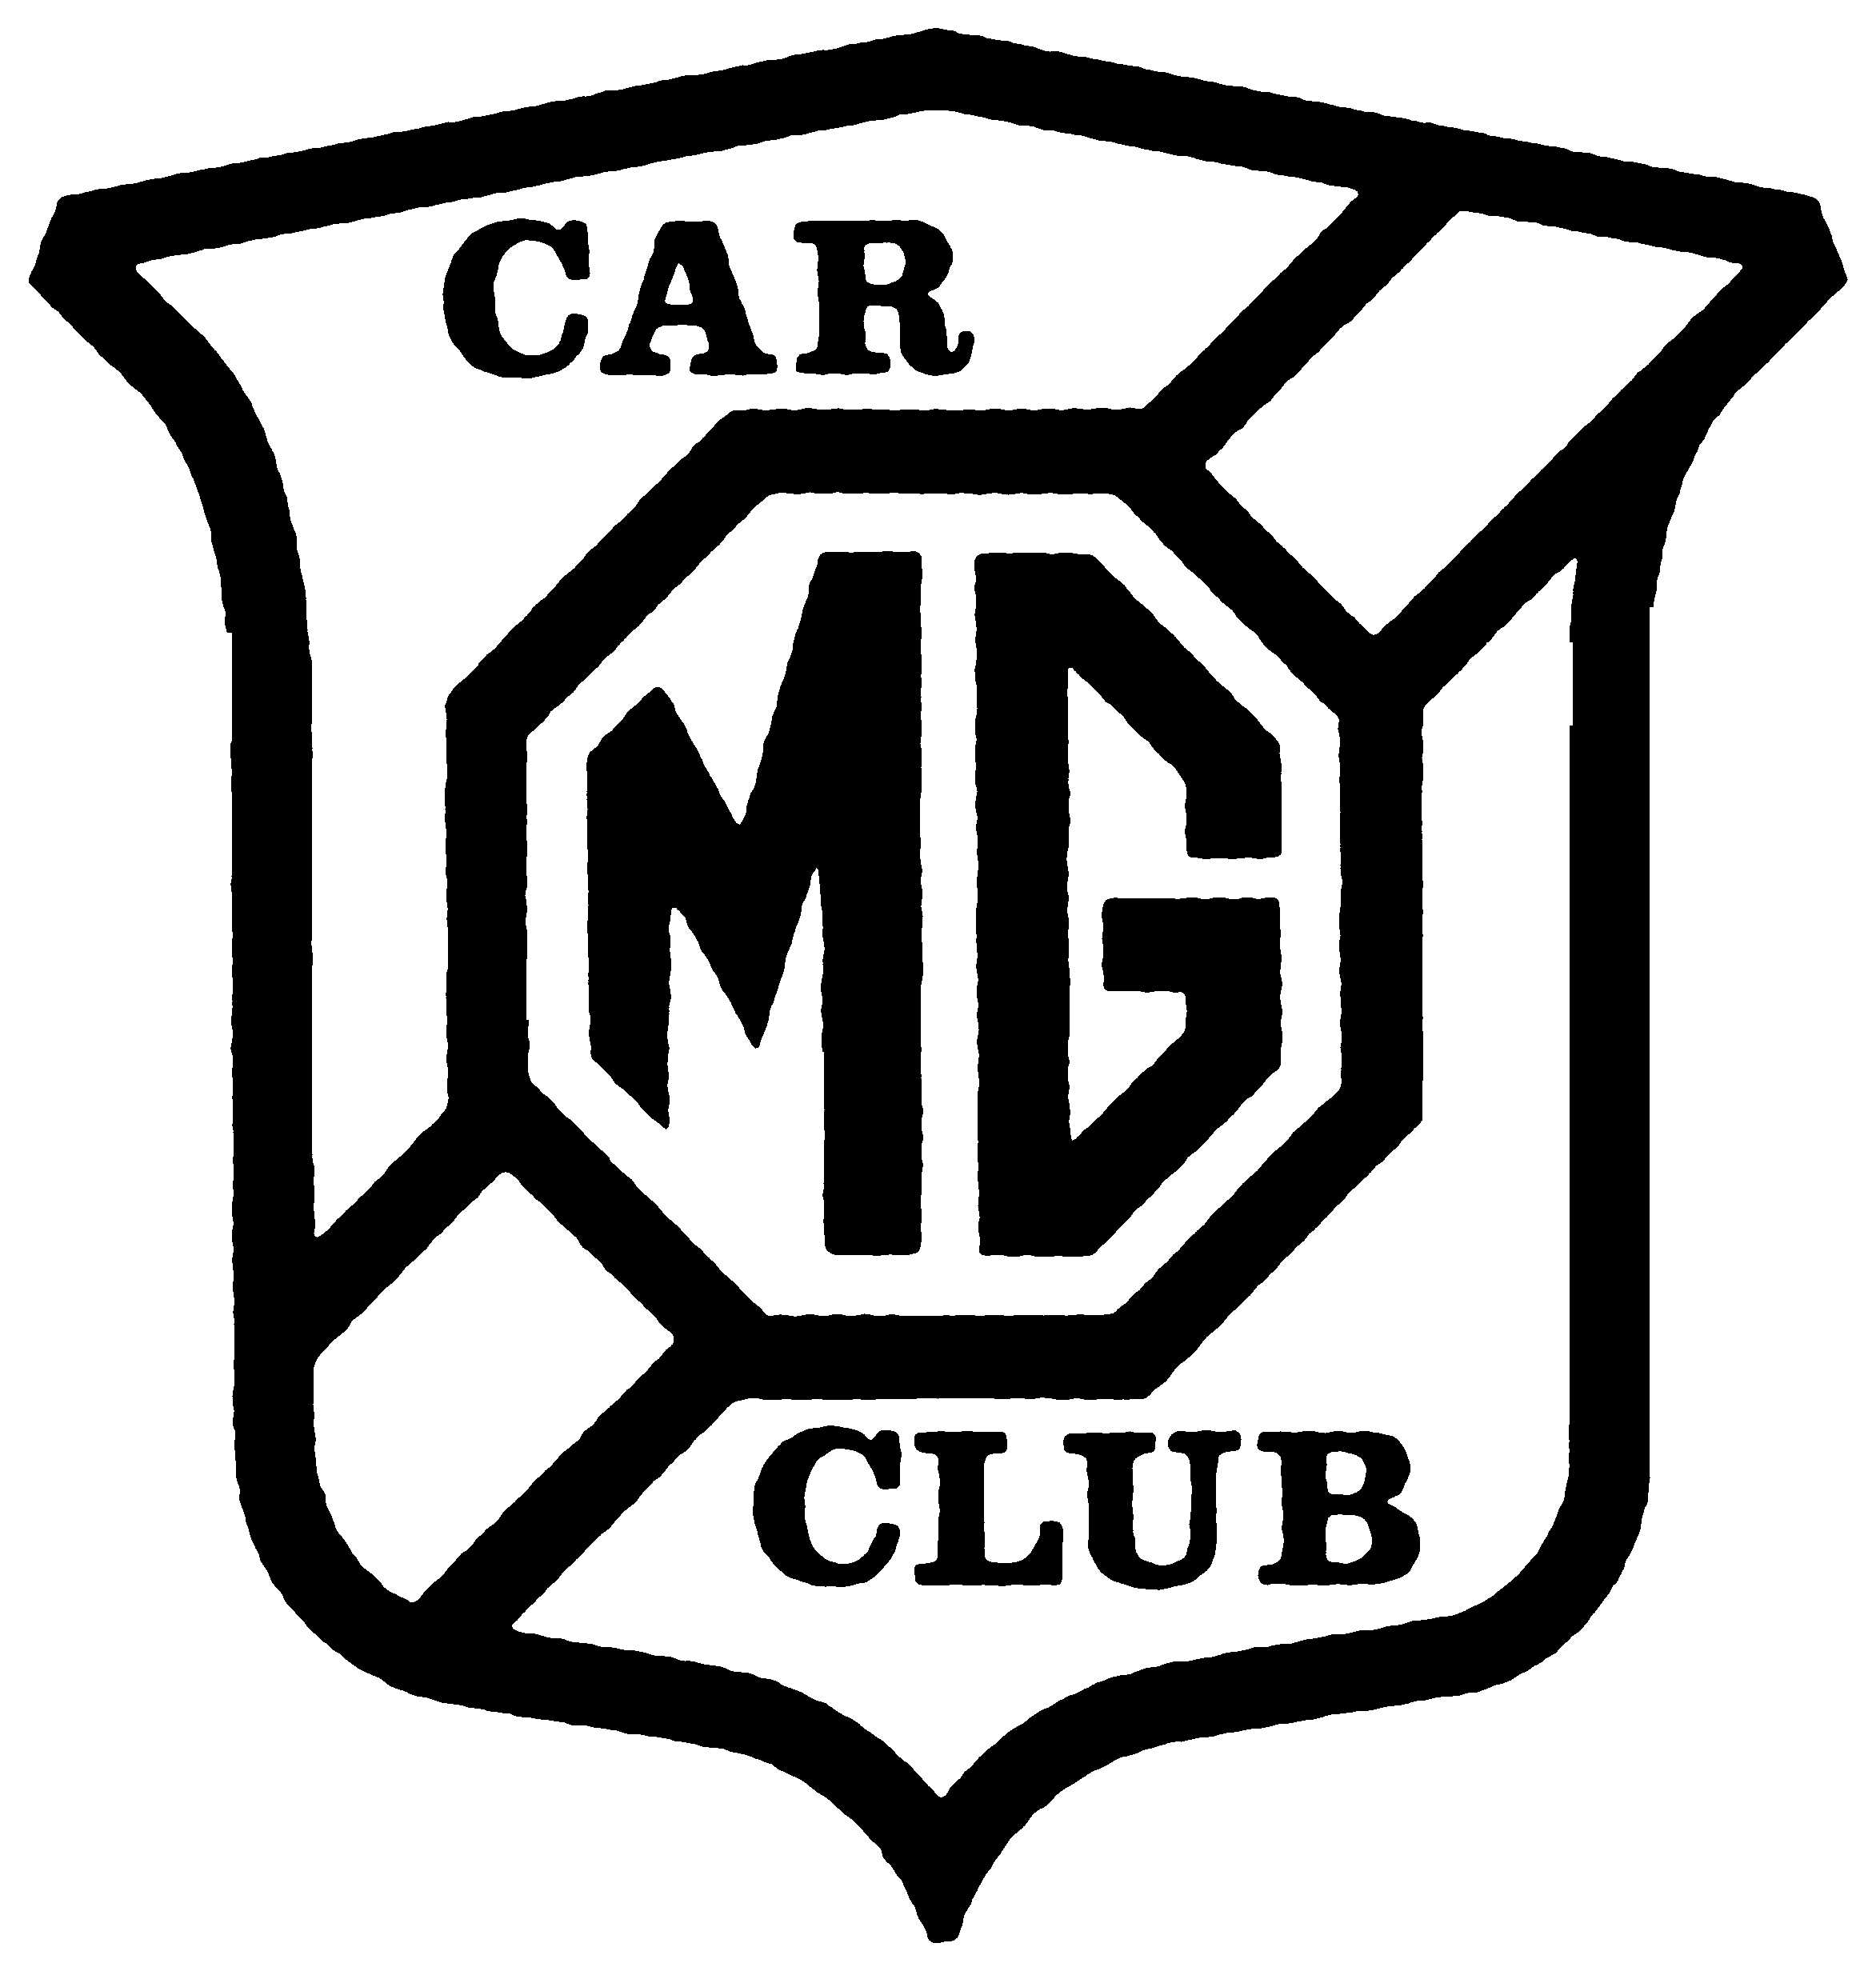

South West Centre of the M.G. Car Club

Hello and welcome to the South. West Centre of the M.G. Car Club

Every year we organise a variety of events for you to come along to and enjoy in your M.G. new or old, whatever the condition. In this diary you will find a list of the regular pub meetings (natters), a calendar to tell you when and where things happen as well as a brief description of what goes on.

The whole purpose is to encourage you to enjoy driving your M.G. with like-minded friends.

Visit the web site at for the latest information, entry forms and so much else or please feel free to call the event organiser we list the names and phone numbers by the event.

We look forward to meeting you soon.

M.G. Car Club South West Committee.

www.mgcars.org.uk/mgccsw
Brief Description of Events

South West Centre Championship All SW centre members get free entry in the South West Drivers' Championship, see our Web site for details.

Autotest. A timed event that consists of a number of routes around bollards. Very good entertainment and experience in handling your car safety at low speed.

Auto-Solo. Similar to a large tarmac autotest, turns are generally not as tight as an autotest. Easy to follow course around bollards, hence no chance of getting lost and no reversing. Suitable for any road legal MG.

Gymkhana. Timed and judgement tests, normally on grass, around a course marked out with bollards with several attempts at each test. Tremendous fun and a good lesson in car control on slippery surfaces. Non damaging, ideal for your everyday M.G. Passengers welcome too!

Kimber Classic Trial. A number. of "gentle", uphill, slippery sections, including a ford, linked by road sections.

Production Car Trial (PCT). Several muddy, slippery uphill "sections" on one site. The further up each section you get the better. Gets your car muddy but tremendous fun. Passengers are mandatory.

Social Run. Often from/to a place of interest down 'B' and 'White' Roads that you never knew were there. Time to look around, have lunch and a chat then home, again.

Sprint. On tarmac timed to 1/100th of a second, very fast. MSA licences, crash helmets and fireproof overalls required.

Wiscombe Hill Climb. An up hill sprint! A stunningly beautiful venue, excellent spectator sport with a wide variety of cars entering. MSA licences, crash helmet and fire proof required.

* Not Competing – Volunteer to Marshal *
Monthly Natter Meetings

1st  Tue. | The Ring O'Bells Compton Martin,  Nr. Bristol | Andrew Owst  01761 221893
 | Plough & Harrow  Llangyfelach,  Swansea | Robin Jones  01792 419780
 | Fighting Cocks  Arreton, Isle of Wight | Ray Sheath,  01983 866493
2nd  Mon. | The Old Court Hotel, Symonds Yat,  Nr. Ross-On-Wye | Terry Davies  01989 562366
2nd Tue. | Three Horse Shoes,  Langley Marsh, Wiveliscombe, Somerset | John Hopkins  01984 629291
Ye Hostelrle Hotel | The Bell  Bowden Hill,  Lacock, Wiltshire | Steve Rogers  01225 769836 Ross on Wye
 | Nantyffin Motel, Llandissilio, Clynderwen | Neil Thomas  01834 845244
2nd Thur. | Lime Kiln Inn  Long Sutton,  Nr. Langport | Barry Foster  01458 850169
3rd  Tue. | Queen's Head Broadchalke, Salisbury | Charles Jones  07767 862751
 | BBC Social Club Lantrisant Road  Llandaff, Cardiff | John Chapman  01292 755295
 | The Bridge Inn  Preston  Dorset | Les Horton 01305 761118

MG CAR CLUB

South West Centre

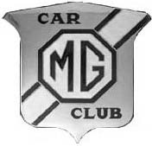
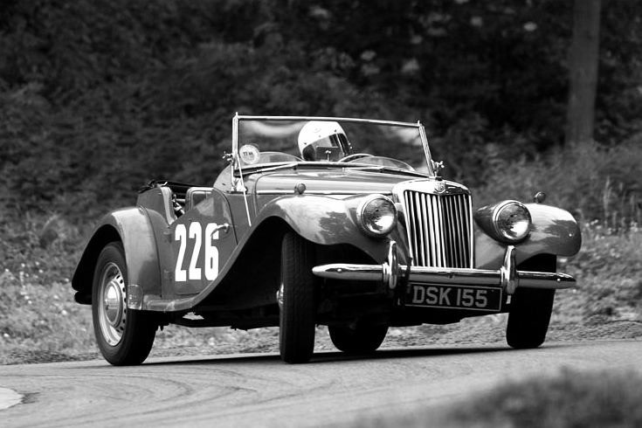
2010 Calendar

Visit the Centre’s web site for the latest information, event regulations and entry forms

www.mgcars.org.uk/mgccsw

Date | Key | Event | Location | Contact |  | Contact No.
February 20 |  | Dinner & Awards Presentation | Limpley Stoke Hotel | John Bird |  | 01179 560175
March 2 |  | AGM | Ring o’ Bells,  Compton Martin | Bruce Weston |  | 01963 440941
21 | Mid-C | Spring Trial | Near Ledbury | Tony Lake | 01604 589104
April 17 | (C) | Kimber Classic Trial | Sherborne | Andrew Owst |  | 01761 221893
18 | (C) | Kimber Classic Gymkhana | Near Glastonbury | Andrew Owst |  | 01761 221893
May 1-2 |  | Bristol Classic Car Show | Bath & West Show Ground | Bruce Weston |  | 01963 440941
3 | (C) (SC) | Wessex Sprint | Colerne, Nr Bath | Bruce Morgan |  | 01275 790855
8-9 | Rotary Club | Classic Car Event | Prescott Hill Climb | www.cleevevale.org.uk
16 | (C) | Wye Valley Social Run | Ross-on-Wye | Terry Davies |  | 01989 562366
23 | (C) | Bath Gymkhana | A46 North of Bath | Peter Jones |  | 01225 837545
June 4-6 | MGCC  (C)  (C) (SC) | Silverstone International California Cup Autotest  Sprint | Silverstone | www.mgcc.co.uk
14 | MGOT | Track Day | Castle Combe | www.mgs-on-track.com
19 | (C) BPMC | Auto-Solo | Chepstow Race Course | John Delafield |  | 01453 544497
July 4 | (C) | MG AutoAero Day | A 30 Henstridge  Nr Templecombe | Tony Blake |  | 01179 790108
August 1 | (C) | Chew Valley Gymkhana | South Bristol | Dave Coppock |  | 01934 834429
8 | P-MGCC | Pendine Dash | Pembrokeshire | www.pembsmg.co.uk
22 | (C) | Mendip PCT | Chew Stoke | Bruce Weston |  | 01963 440941
30 | BPMC/BMC | 2 Club Sprint | Colerne (Nr Bath) | Bruce Morgan |  | 01275 790855
September 6 | MGOT | Track Day | Castle Combe | www.mgs-on-track.com
11 | (C) (SC) | Wiscombe Hill Climb | Honiton, Devon | Bruce Weston |  | 01963 440941
18 | (C) BPMC | Auto-Solo | Chepstow Race Course | John Delafield |  | 01453 544497
25 | (C) | Treasure Hunt | tba | Andrew Owst |  | 01761 221893
October 3 | (C) | Run to Prescott Hill Climb | Near Cheltenham | Phil Archer |  | 01454 633209
16 | (SC) BPMC | Castle Combe Sprint | Castle Combe | www.bristolpegasus.com
17 | (C) | Kimber Trial | Chew Stoke | Bruce Weston |  | 01963 440941
24 | (C) | National Trust Social Visit | tba | John Bird |  | 01179 560175

Key: South West Centre of the MGCC events are shown in bold

- Round of the MGCC South West Centre Championship
(SC) Round of MGCC Luffield Cars Speed Championship Mid-C Organised by MGCC Midland Centre
BPMC Invite from Bristol Pegasus Motor Club MGOT Organised by MGCC, MGs On Track
P-MGCC Pembroke MG Car Club

