Further copies of these Regulations can be obtained from the websites of the co-promoting clubs

www.mgcars.org.uk/mgccsw
www.bristolpegasus.com
www.bristolmc.org.uk



The Wessex Sprint is a round of the 2010 Bridge Tyres and Wheels ASWMC Sprint Championship

The organising clubs acknowledge the kind permission granted by the Commanding Officer of the Bristol University Air Squadron for the use of this venue.

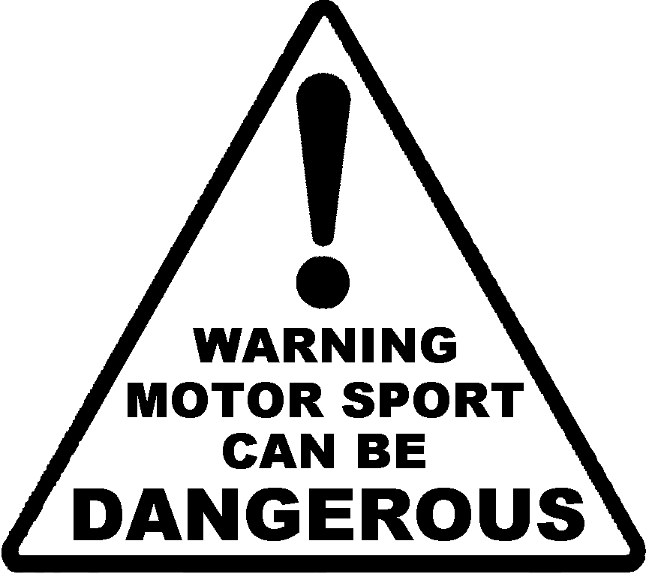

DESPITE THE ORGANISERS TAKING ALL REASONABLE
PRECAUTIONS UNAVOIDABLE ACCIDENTS CAN HAPPEN.
IN RESPECT OF THESE YOU ARE PRESENT AT YOUR OWN RISK

